
Egypt University of Informatics
Computer and Information Systems
Data Analysis Course

The Analysis of Cairo Weather Data

Submitted by: Farida Osama / 24-101513
Hana Ahmed / 24-101108
Tasnem Ahmed / 24-101166
Abdelrahman Ahmed / 24-101501

2/5/2026

Introduction:

Weather plays a vital role in our daily lives, influencing everything from what we wear to how we plan our activities. In cities like Cairo, where temperatures can reach high levels, understanding weather patterns is especially important for public health, energy consumption, and overall quality of life. Studying how temperature changes over time can also provide insights into broader environmental issues such as climate change.
This report focuses on analyzing historical weather data from Cairo to explore temperature trends over the years. By examining patterns in the data using statistical methods and visualizations, we aim to determine whether temperatures are increasing, decreasing, or remaining stable. Understanding these trends is important not only for academic purposes but also for raising awareness about potential long term environmental changes.

Research Question:
Has Cairo’s average annual temperature increased significantly between 2009 & 2024 based on statistical analysis, and if so, what’s the rate of change?

Hypothesis:
H0: There is no significant linear relationship between year and the average temperature in Cairo (slope = 0).
H1: There is a significant linear relationship between year and the average temperature in Cairo (slope ≠ 0).

Dataset Description:

The dataset used in this analysis contains historical weather data for Cairo, Egypt. It was sourced from Open-Meteo Historical Weather API and is available on Kaggle.
The dataset includes several weather-related variables such as daily temperature, minimum and maximum temperature. These variables allow us to analyze weather conditions and identify patterns over time.
The data spans from Feb 1, 2009, to Dec 31, 2024 which makes it suitable for studying long term temperature trends and seasonal variations.
During preprocessing, the dataset was checked for missing values and inconsistencies. Any irrelevant columns were removed, and the data was verified to ensure accuracy and consistency. Additionally, the data was aggregated into yearly averages to reduce daily fluctuations and better highlight long-term trends in temperature over time.
- Number of samples used: 5,813 observations.
Each row represents one day and includes the following variables in columns:
- Time: The date of the observation
- Temperature: Average daily temperature (°C) which is the main variable used in this analysis
- Temperature_min: The lowest daily temperature (°C)
- Temperature_max: The highest daily temperature (°C)
The focus in this report is on the temp variable, which is analyzed over time to identify any statistically significant trends in Cairo’s climate

Analysis:
To analyze the data, the average temperature for each year was calculated to observe long-term trends.
Several visualizations techniques were used, including scatter plots, line charts and regression plots, to examine the relationship between year and temperature. A linear regression model was applied to quantify the trend and determine whether the observed changes were statistically significant.
These methods allow both visual and statistical evaluation of temperature patterns over time.

Figure 1: Temperature Trend Scatter Plot
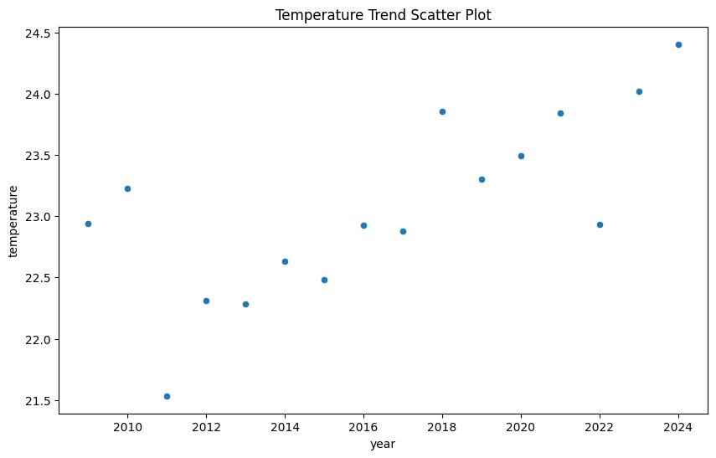
- The scatter plot illustrates yearly temperature variations, showing an overall upward trend. While there are fluctuations, such as the noticeable dip in 2011, the general pattern indicates higher temperatures in later years.
This suggests a positive association between time and temperature, indicating a gradual warming trend rather than random variation.

Figure 2: Average temperature over years
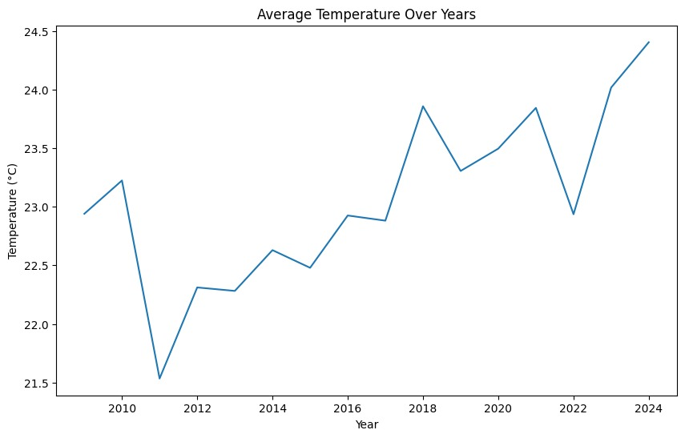
- The line chart highlights the progression of average yearly temperature over time. Although short-term fluctuations are present, a clear upward trend is visible particularly after 2015. The increase from approximately 21.6 °C in 2011 to about 24.4 °C in 2024 reflects a noticeable long-term rise, supporting the presence of a warming pattern.

Figure 3: Regression line for temperature trend
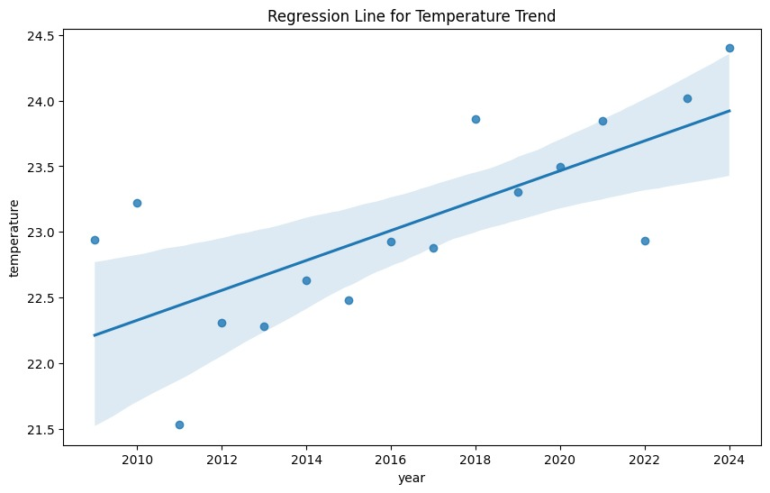
- The regression plot shows a positive linear relationship between year and temperature. The estimated slope of the regression line is approximately + 0.113°C per year, indicating a consistent annual increase in temperature.
The p-value obtained from the regression analysis is 0.0014 (<0.05), confirming that the observed trend is statistically significant.
The confidence interval around the regression line indicates reliability of the estimate, and most data points lie close to the line, suggesting a good model fit.

Figure 4: Summer vs Winter temp trends in Cairo over years
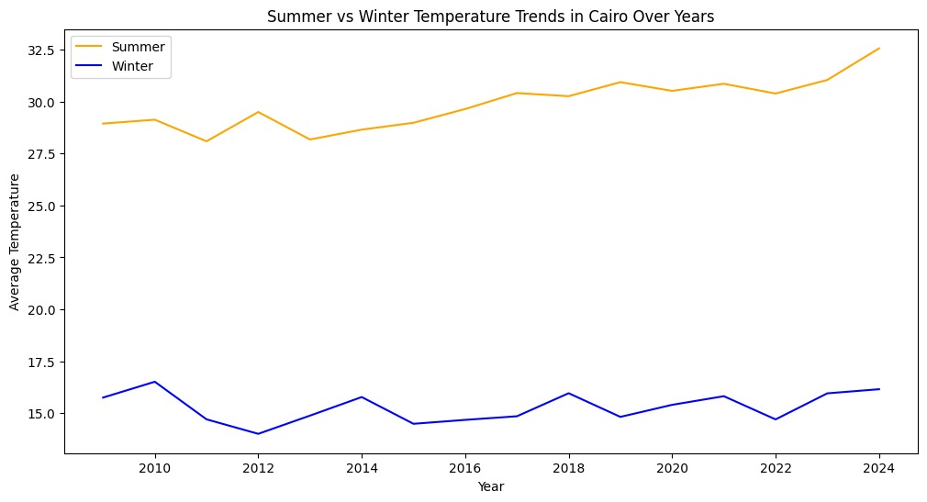
- The seasonal analysis reveals that temperature trends differ significantly between summer and winter.
Summer temperatures show a strong increasing trend, rising from approximately 29°C to over 32.5°C, while winter temperatures remain relatively stable with only a slight increase.
This indicates the overall warming trend in Cairo is primarily driven by increases in summer temperatures, suggesting that extreme heat conditions are becoming more intense over time rather than uniform warming across all seasons.

Hypothesis Testing Steps:

- Step 1: State the hypotheses:
H0: The slope of regression line is equal to 0 (no relationship).
H1: The slope of regression line is not equal to 0 (significant relationship).
- Step 2: Significance level:
A significance level of α = 0.05 was used
- Step 3: Statistical test:
A linear regression was performed using linregress to calculate the slope and p-value. The computed slope was + 0.113°C per year and the p-value was 0.0014.
- Step 4: Decision:
Since the p-value (0.0014) is less than 0.05, we reject the null hypothesis.
Conclusion:
Based on both visual and statistical analysis, there is clear evidence of an increasing temperature trend in Cairo between 2009 and 2024. The regression analysis indicates that temperature is rising at an approximate rate of 0.113°C per year, and the p-value confirms that this trend is statistically significant. Therefore, we reject the null hypothesis and conclude that there is a meaningful relationship between time and temperature. Furthermore, the seasonal analysis shows that this warming trend is primarily driven by increasing summer temperatures, suggesting a rise in extreme heat conditions rather than uniform warming across all seasons. These findings may indicate early signs of long-term climate change effects in the region.
Any potential issues:
First, the dataset covers the period from 2009 to 2024 only, which may not be sufficient to fully represent long term climate trends.
Second, the data is limited to a single location (Cairo), so the results cannot be generalized to other regions or global climate patterns.

